CONTENTS

- Introduction
- Overview
- Introduction to JAVA
- ER Diagram
- Converting ER Diagram into Tables
- Table Structures
- Code
- Snapshots
- Conclusion
- Scope of Enhancement

1. ABSTRACT

The Project title Library Management system is the Library Management Web Application for monitering and controlling the transcation in the Library. The project “Library management System” is developed in JSP and Servlets, which mainly focuses on basic operations in a library like adding new member, new books, and updating new information, searching books and members and facility to borrow.

FEATURES
- Administrator login.
- Student login.
- Registration of Student, their information.
- Scope for adding new Books.
WHAT IMPACT DOES IT HAVE
- Easy for the student to purchase the book.
- Show the history of the Books purchased.
- Easy to add the Books to the Library by the Admin.
- Secured Login by both Student and Admin.
- Register Easily by the students for accessing the Online Library.

2. INTRODUCTION
PURPOSE
- The purpose of Library Management System is to purchase the book easily by the students.

- The main objective of on-line Library Management is a project that manages and stores books information electronically according to students.

- For Administrator they can easily add the new variety of the Books to the Library by just Login into their account.

SCOPE
Scope of this project is very broad in terms of other manually things.
Few of them are:-
- This can be used in educational institutions as well as in corporate world for students for purchasing the Book.
- According to that the Admin they can easily add their book.
- Notification of the Due Date of the books can be implemented for the students. That they could easily return or renew the book.

FEATURES:
- Secure
- Easy to use
- Reliable and accurate
- No need of paper work

LOGIN:-
- There is a quality login window because this is more secure than other login forms as in a normal login window there are multiple logins available so that more than one person can access to forms with their Roll Number.
- It include two login windows one for administrator and another one for student.

FORM FIILING:
- It consists of two main pages:
- Feedback page is the most creative and important page in this project.
  - Branch, Faculty name, Year, and Subject selection.
  - Filling the form according to the user’s wish.
- Result Table generation.
  - Branch, Faculty name, and Subject selection.
  - Calculating the index on bases of certain rules and regulation.

TECHNOLOGIES USED

- Front end as:
Eclipse Platform

- Back end as:
MySQL

- Database:
MySQL

- Querying language:
MySQL

3. SPECIFIC REQUIREMENTS:

External interface utilised:

HARDWARE
1.) Minimum 5 GB space in HDD
2.) IBN Net vista Pentium 4 1.7 GHz
3.) 256 MB DDR SDRAM
4.) GB ULTRA HDD 7200 RPM
5.) 48 x CD ROM
6.) 15 `` colour monitor

SOFTWARE
1. Netbeans Platform
2. Windows 10(Pro)
3. JDBC Driver
4. MySQL

Introduction to Java
- Java is Object oriented, Multi-threading language developed by Sun Microsystems in 1991.
- It is designed to be small, simple and portable across different platforms as well as OS.
Features of Java:
Syntax based on C++
- Object-oriented
- Support for Internet applications
- Extensive library of prewritten classes
- Portability among platforms
- Built-in networking security as JRE is inaccessible to other parts of computer
Java Programs:
- Applets:
  - Small programs designed to add interactivity to Web sites
  - Downloaded with the Web page and launched by the Internet browser
- Servlets :
  - Run by Web server on the server
  - Typically generate Web content
- Applications:
  - Programs that run standalone on a client

Java Servlets:
- Servlets are server side applets that are loaded and executed by a web server in the same manner that applets are loaded and executed by a web browser.
- Java Servlets are useful to create Dynamic pages. Depending upon my input server will give an output
Features of Servlets:
- Database Connectivity
  - Insert/Update/delete/drop
  - Select
- Servlets Chaining
- Server Side Includes
- Applet Servlet Communication
- Inter-servlet Communication
- Page Compilation
- Session Tracking
JSP:
Introduction:
- As a Java-based technology, it enjoys all of the advantages that the java language provides with respect to development and deployment.
- JSP runs on major web platforms.
- Client (web browser) makes a request via an HTTP.
- The web server receives the request and sends it to the Servlets/JSP engine. If the Servlets/JSP is not loaded, the web server will load it into the JVM and execute it.
- Web server returns response to the Client.

JSP Directives: They generate side effects that are change the way the JSP container processes the page.

Implicit Objects:
  - Request
  - Response
  - Session
  - Application
  - Page Context
  - Exception
JSP Actions: The JSP actions allow the transfer of control between pages.
- Forward
- Include
- Plug-in
JavaScript:
A scripting language is a lightweight programming language which is basically responsible for
  - Creating Dynamic Pages.
  - Respond to the events.
  - Read and Write HTML Elements.
  - Validate Data.
Functions:
- Functions are useful to a programmer when certain tasks are to be repeated during the course of the program. They are defined by name and invoked with the same. The functions can take parameters and return result using return statement.
- Recursive Functions are functions that call themselves.
Events:
- Events are signals generated when specific event occurs. Event handlers are scripts written by the programmer to take advantages of events in JavaScript. Eg:
blur : Occurs when user clicks outside a field.
click: Occurs when user clicks inside a field.
change: Occurs when user changes a field.
focus : Occurs when user focuses over a field

E-R diagram
Administrator

UPDATES
BookName

Author
id

Book Info
Category
id

optgiven
id

password
id

rollno
rollno
password
id

1

register
student Question
Registration form
gets
FirstName
id

LastName
id

department

year
id

Author
BookName

id

1
section
id

category
Books Question

CONVERTING E-R INTO TABLES

ADMININFO

COLUMN NAME | TYPE | SIZE | CONSTRAINTS
MAILID | VARCHAR | 50 | PRIMARY KEY, UNIQUE, NULL
PASSWORD | VARCHAR | 50 | NULL
BOOK

COLUMN NAME | TYPE | SIZE | CONSTRAINTS
BOOK NAME | VARCHAR | 50 | PRIMARY KEY, UNIQUE, NULL
CATEGORY | VARCHAR | 50 | NULL
AUTHOR | VARCHAR | 50 | PRIMARY KEY, UNIQUE, NULL
BOOK HISTORY

COLUMN NAME | TYPE | SIZE | CONSTRAINTS
BOOK NAME | VARCHAR | 50 | NULL
AUTHOR | VARCHAR | 50 | NULL
CATEGORY | VARCHAR | 50 | NULL
ROLL NO | VARCHAR | 50 | NULL

STUDENT DETAILS
COLUMN NAME | TYPE | SIZE | CONSTRAINTS
FIRST NAME | VARCHAR | 50 | NULL
LAST NAME | VARCHAR | 50 | NULL
CURRENTYEAR | VARCHAR | 50 | NULL
DEPARTMENT | VARCHAR | 50 | NULL
SECTION | VARCHAR | 50 | NULL
ROLL NO | VARCHAR | 50 | PRIMARY KEY, UNIQUE
PASSWORD | VARCHAR | 50 | NULL

RELATIONAL DATABASE DESIGN

The database consists of following tables:
- Admin Info
- Book
- Book History
- Student Details

- Admin Info table will the contain the Information of the Administrator, Only the administrator could add the Book.
- Book Table will contains the Book added by the Administrator.
- Book History table will contain the history of the Book purchased by the students.
- Student Details will contain the information of the student.

SOURCE CODE
PAGE: index.html
<html>
<head>
<meta name="viewport" content="width=device-width, initial-scale=1">
<script>
function myFunction() {
var x = document.getElementById("myInput");
if (x.type === "password") {
x.type = "text";
} else {
x.type = "password";
}
}

</script>
<link href="style.css" rel="stylesheet" type="text/css">

</head>
<body>

<form action="login" method="post">
<div class="container">

<h3><b><center>Student Login</center></b></h3>
<hr>

<label for="uname"><b>Roll No</b></label>
<input style="text-transform: uppercase;" type="text" name="uname" required>

<label for="psw"><b>Password</b></label>
<input type="password" name="password1" id="myInput" required>

<input type="checkbox" onclick="myFunction()">Show Password

<hr>
<center> <input class="registerbtn" type="submit" value="Login"></center>
<p>Don't have an account? <a href="StudentRegister.jsp" target="f2">Click Here</a></p>
<br>
<p>Admin Login? <a href="AdminRegister.jsp" target="f2">Click Here</a></p>
</div>
</form>
</body>
</html>
PAGE: AdminRegister.jsp
<%@page contentType="text/html" pageEncoding="UTF-8"%>
<!DOCTYPE html>
<!DOCTYPE html>
<html>
<head>
<meta name="viewport" content="width=device-width, initial-scale=1">
<script>
function myFunction() {
var x = document.getElementById("myInput");
if (x.type === "password") {
x.type = "text";
} else {
x.type = "password";
}
}
</script>
<link href="style.css" rel="stylesheet" type="text/css">
</head>
<body>
<form action="AdminLogin" method="post">
<div class="container">
<h3><b><center>Staff Login</center></b></h3>
<hr>
<label for="uname"><b>User Name</b></label>
<input type="text" placeholder="Enter Email" name="uname" pattern="[a-z0-9._%+-]+@[a-z0-9.-]+\.[a-z]{2,}$" required>
<label for="psw"><b>Password</b></label>
<input type="password" placeholder="Enter Password" name="password1" id="myInput" required>
<input type="checkbox" onclick="myFunction()">Show Password
<hr>
<center> <input class="registerbtn" type="submit" value="Login"></center>
</div>
</form>
</body>
</html>
PAGE: AdminAdd.jsp
<%@page contentType="text/html" pageEncoding="UTF-8"%>
<!DOCTYPE html>
<!DOCTYPE html>
<html>
<head>
<meta name="viewport" content="width=device-width, initial-scale=1">
<link href="style.css" rel="stylesheet" type="text/css">

</head>
<body>

<form action="addbook" onSubmit = "return checkPassword(this)">
<div class="container">
<h1>Register</h1>
<p>Please fill in this form to create an account.</p>
<hr>

<label for="fname"><b>Enter the Book Name</b></label>
<input type="text" placeholder="Enter First Name" name="bookname" required>

<label for="lname"><b>Enter the Author</b></label>
<input type="text" placeholder="Enter Last Name" name="author" required>

<label for="lname"><b>Book Category</b></label><br>
<select name="category" >
<option value="Engineering">Engineering</option>
<option value="Communication">Communication</option>
<option value="Adventure">Adventure</option>
<option value="Maths">Maths</option>
<option value="Humanities&Science">Humanities&Science</option>
</select>

<hr>

<center> <input class="registerbtn" type="submit" value="Submit"></input></center>
</div>

<div class="container signin">
<p>Logout? <a href="index.html">Click here</a>.</p>
</div>
</form>

</body>
</html>
PAGE: Welcome.jsp

<%@page import="java.sql.ResultSet"%>
<%@page import="java.sql.DriverManager"%>
<%@page import="java.sql.DriverManager"%>
<%@page import="java.sql.PreparedStatement"%>
<%@page import="java.sql.Connection"%>
<%@page contentType="text/html" pageEncoding="UTF-8"%>
<!DOCTYPE html>
<html>
<head>

<title>Panimalar Library</title>
<link href="style.css" rel="stylesheet" type="text/css">
</head>
<%
try

{

String ROLLNO = request.getParameter("email");

Class.forName("org.apache.derby.jdbc.ClientDriver");
Connection con = (Connection) DriverManager.getConnection("jdbc:derby://localhost:1527/LIBRARY","KBKR","KBKR");
PreparedStatement ps=con.prepareStatement("select * from KBKR.STUDENTDETAILS where ROLLNO=?");
ps.setString(1, ROLLNO);
ResultSet rs=ps.executeQuery();
while(rs.next())
{
%>
<frameset rows="20%,*" >
<frame src="Title.jsp?email=<%=rs.getString("FIRSTNAME")%>" noresize="noresize" scrolling="no"></frame>
<frameset cols="20%,*">
<frame src="StudentPanel.jsp?email=<%=rs.getString("ROLLNO")%>" name="s1" noresize="noresize"></frame>
<frame src="Student.jsp?email=<%=rs.getString("ROLLNO")%>" name="s2" ></frame>
</frameset>
<%
}
con.close();
}
catch(Exception e)
{
System.out.println(e);
}
%>
</frameset>
</html>
PAGE:title.jsp

<%@page contentType="text/html" pageEncoding="UTF-8"%>
<!DOCTYPE html>
<html>
<head>
<meta http-equiv="Content-Type" content="text/html; charset=UTF-8">
<title>JSP Page</title>
</head>
<body>
<h1><center>Panimalar Online Library</center></h1>
<br>
<%
String firstname=request.getParameter("email");
%>
<p>Welcome:<%=firstname%><p>
</body>
</html>
PAGE:StudentPanel.jsp

<%@page contentType="text/html" pageEncoding="UTF-8"%>
<!DOCTYPE html>
<html>
<head>
<meta http-equiv="Content-Type" content="text/html; charset=UTF-8">
<title>JSP Page</title>
<link href="style.css" rel="stylesheet" type="text/css">
</head>
<body class="container">

<%
String rollno=request.getParameter("email");
%>
<a href="Student.jsp?email=<%=rollno%>" target="s2">Book Ticket</a>
<br>
<hr>
<br>
<br>
<a href="BookPurchased.jsp?email=<%=rollno%>" target="s2">Book Purchased</a>
<br>
<hr>
<br>
<br>

<a href="index.html?email=<%=rollno%>" target="_PARENT">Logout</a>
<br>
<hr>
<br>
<br>
</body>
</html>
PAGE: Student.jsp

<%@page contentType="text/html" pageEncoding="UTF-8"%>
<!DOCTYPE html>
<html>
<head>
<meta http-equiv="Content-Type" content="text/html; charset=UTF-8">
<title>JSP Page</title>
<link href="style.css" rel="stylesheet" type="text/css">
</head>
<body>
<%
String email=request.getParameter("email");

%>
<div class="container">

<form action="DisplayBooks.jsp">
<label>Roll No</label>
<input type="text" value="<%=email%>" name="email"/>
<label>Select the Category of Books</label>
<select name="category" >
<option value="Engineering">Engineering</option>
<option value="Communication">Communication</option>
<option value="Adventure">Adventure</option>
<option value="Maths">Maths</option>
<option value="Humanities&Science">Humanities&Science</option>

</select>
<input type="submit" value="submit"/>
</form>
</div>
</body>
</html>
PAGE: DisplayBooks.jsp

<%@page import="java.sql.ResultSet"%>
<%@page import="java.sql.PreparedStatement"%>
<%@page import="java.sql.PreparedStatement"%>
<%@page import="java.sql.DriverManager"%>
<%@page import="java.sql.PreparedStatement"%>
<%@page import="java.sql.DriverManager"%>
<%@page import="java.sql.PreparedStatement"%>
<%@page import="java.sql.Connection"%>
<%@page contentType="text/html" pageEncoding="UTF-8"%>

<html>
<head>
<meta http-equiv="Content-Type" content="text/html; charset=UTF-8">
<link href="style.css" rel="stylesheet" type="text/css">
<title>JSP Page</title>
</head>
<body>
<div class="container">
<%
try

{

String email=request.getParameter("email");

String CATEGORY = request.getParameter("category");

Class.forName("org.apache.derby.jdbc.ClientDriver");
Connection con = (Connection) DriverManager.getConnection("jdbc:derby://localhost:1527/LIBRARY","KBKR","KBKR");
PreparedStatement pst=con.prepareStatement("select * from KBKR.BOOK where CATEGORY=?");

pst.setString(1, CATEGORY);

ResultSet rs=pst.executeQuery();

%>
<p><%=email%></p>
<table id="customers">
<tr>
<th>ROLL NO</th>
<th>BOOK NAME</th>
<th>AUTHOR</th>
<th>CATEGORY</th>
<th>PURCHASE</th>

</tr>
<%

while(rs.next())
{
%>

<tr>
<form action="Purchase">
<td><p><input type="text" value="<%=email%>" name="email" readonly/></p></td>
<td><p><input type="text" value="<%=rs.getString("BOOKNAME")%>" name="bookname" readonly/></p></td>
<td><p><input type="text" value="<%=rs.getString("AUTHOR")%>" name="author" readonly/></p></td>
<td><p><input type="text" value="<%=rs.getString("CATEGORY")%>" name="category" readonly/></p></td>

<td><input type="submit" value="Purchase Book"></td>
</form>
</tr>
<%

}
con.close();
}
catch(Exception e)
{
String email=request.getParameter("ROLLNO");
out.print("There is no Book available");
RequestDispatcher rd=request.getRequestDispatcher("Book.jsp?email="+email+")");
rd.include(request,response);
System.out.println(e);
}

%>
</div>
</body>
</html>

</body>
</html>
PAGE: BookPurchased.jsp

<%@page import="java.sql.ResultSet"%>
<%@page import="java.sql.PreparedStatement"%>
<%@page import="java.sql.PreparedStatement"%>
<%@page import="java.sql.DriverManager"%>
<%@page import="java.sql.PreparedStatement"%>
<%@page import="java.sql.DriverManager"%>
<%@page import="java.sql.PreparedStatement"%>
<%@page import="java.sql.Connection"%>
<%@page contentType="text/html" pageEncoding="UTF-8"%>

<html>
<head>
<meta http-equiv="Content-Type" content="text/html; charset=UTF-8">
<link href="style.css" rel="stylesheet" type="text/css">
<title>JSP Page</title>
</head>
<body>
<div class="container">
<%
try

{

String email = request.getParameter("email");

Class.forName("org.apache.derby.jdbc.ClientDriver");
Connection con = (Connection) DriverManager.getConnection("jdbc:derby://localhost:1527/LIBRARY","KBKR","KBKR");
PreparedStatement pst=con.prepareStatement("select * from KBKR.BOOKHISTORY where ROLLNO=?");

pst.setString(1, email);

ResultSet rs=pst.executeQuery();

%>
<p><%=email%></p>
<table id="customers">
<tr>
<th>BOOK NAME</th>
<th>AUTHOR</th>
<th>CATEGORY</th>

</tr>
<%

while(rs.next())
{
%>

<tr>
<td><p><%=rs.getString("BOOKNAME")%></p></td>
<td><p><%=rs.getString("AUTHOR")%></p></td>
<td><p><%=rs.getString("CATEGORY")%></p></td>

</tr>
<%

}
con.close();
}
catch(Exception e)
{
System.out.println(e);

String email=request.getParameter("email");
out.print("There is no Book available");
RequestDispatcher rd=request.getRequestDispatcher("Book.jsp?email="+email+")");
rd.include(request,response);
System.out.println(e);
}

%>
</div>
</body>
</html>

</body>
</html>
PAGE: StudentRegister.jsp
<%@page contentType="text/html" pageEncoding="UTF-8"%>
<!DOCTYPE html>
<!DOCTYPE html>
<html>
<head>
<meta name="viewport" content="width=device-width, initial-scale=1">
<link href="style.css" rel="stylesheet" type="text/css">
<script>

function checkPassword(form) {
password1 = form.password1.value;
password2 = form.password2.value;

if (password1 == '')
alert ("Please enter Password");

else if (password2 == '')
alert ("Please enter confirm password");

else if (password1 !== password2) {
alert ("\nPassword did not match: Please try again...");
return false;
}

}
</script>
</head>
<body>

<form action="Register" onSubmit = "return checkPassword(this)">
<div class="container">
<h1>Register</h1>
<p>Please fill in this form to create a Library account.</p>
<hr>

<label for="fname"><b>First Name</b></label>
<input type="text" placeholder="Enter First Name" name="fname" required>

<label for="lname"><b>Last Name</b></label>
<input type="text" placeholder="Enter Last Name" name="lname" required>

<label for="lname"><b>Current Year</b></label><br>
<select name="year" >
<option value="First Year">First Year</option>
<option value="Second Year">Second Year</option>
<option value="Third Year">Third Year</option>
<option value="Fourth Year">Fourth Year</option>

</select>

<label for="lname"><b>Department</b></label><br>
<select name="department" >
<option value="Mech">Mech</option>
<option value="ECE">ECE</option>
<option value="EEE">EEE</option>
<option value="IT">IT</option>
<option value="CSE">CSE</option>

</select>

<label for="lname"><b>Section</b></label><br>
<select name="section" >
<option value="A">A</option>
<option value="B">B</option>
<option value="C">C</option>
<option value="D">D</option>
<option value="E">E</option>

</select>

<br>
<label for="email"><b>Roll No</b></label>
<input style="text-transform: uppercase;" type="text" placeholder="Enter Roll No" name="rollno" required>

<label for="psw"><b>Password</b></label>
<input type="password" placeholder="Enter Password" name="password1" pattern=".{6,}" required>

<label for="psw"><b>Repeat Password</b></label>
<input type="password" placeholder="Enter Password" name="password2" pattern=".{6,}" required>

<hr>

<center> <input class="registerbtn" type="submit" value="Submit"></input></center>
</div>

<div class="container signin">
<p>Already have an account? <a href="login.jsp">Sign in</a>.</p>
</div>
</form>

</body>
</html>
PAGE: AdminLogin.java

import java.io.IOException;
import java.io.PrintWriter;
import javax.servlet.RequestDispatcher;
import javax.servlet.ServletException;
import javax.servlet.annotation.WebServlet;
import javax.servlet.http.HttpServlet;
import javax.servlet.http.HttpServletRequest;
import javax.servlet.http.HttpServletResponse;

/**
*
* @author karth
*/
@WebServlet(urlPatterns = {"/AdminLogin"})
public class AdminLogin extends HttpServlet {

/**
* Processes requests for both HTTP <code>GET</code> and <code>POST</code>
* methods.
*
* @param request servlet request
* @param response servlet response
* @throws ServletException if a servlet-specific error occurs
* @throws IOException if an I/O error occurs
*/
protected void processRequest(HttpServletRequest request, HttpServletResponse response)
throws ServletException, IOException {
response.setContentType("text/html;charset=UTF-8");
try (PrintWriter out = response.getWriter()) {
/* TODO output your page here. You may use following sample code. */
String name=request.getParameter("uname");
String pass=request.getParameter("password1");

if(adminLoginDao.validate(name, pass))
{

out.println("<html><body>");
out.println("<script type=\"text/javascript\">");
out.println("names = document.getElementById('uname');");

out.println("window.open(\"AdminAdd.jsp?email="+ name +"\", \"_parent\");");
out.println("</script>");
out.println("</body></html>");

}
else
{
out.print("<p style=\"background-color:floralwhite;\" >Sorry username or password error!!!!!!!!</p>");
RequestDispatcher rd=request.getRequestDispatcher("AdminRegister.jsp");
rd.include(request,response);
}
}
}

PAGE: LoginDao.java
import java.sql.*;

public class LoginDao {
public static boolean validate(String name,String pass){
boolean status=false;
try{
Class.forName("org.apache.derby.jdbc.ClientDriver");
Connection con=DriverManager.getConnection(
"jdbc:derby://localhost:1527/LIBRARY","KBKR","KBKR");

PreparedStatement ps=con.prepareStatement(
"select * from KBKR.STUDENTDETAILS where ROLLNO=? and PASSWORD=?");
ps.setString(1,name);
ps.setString(2,pass);

ResultSet rs=ps.executeQuery();
status=rs.next();

}catch(Exception e){System.out.println(e);}
return status;
}
}
PAGE: LoginDao.java
import java.io.IOException;
import java.io.PrintWriter;
import java.sql.Connection;
import java.sql.DriverManager;
import java.sql.PreparedStatement;
import javax.servlet.RequestDispatcher;
import javax.servlet.ServletException;
import javax.servlet.annotation.WebServlet;
import javax.servlet.http.HttpServlet;
import javax.servlet.http.HttpServletRequest;
import javax.servlet.http.HttpServletResponse;

/**
*
* @author karth
*/
@WebServlet(urlPatterns = {"/Purchase"})
public class Purchase extends HttpServlet {

/**
* Processes requests for both HTTP <code>GET</code> and <code>POST</code>
* methods.
*
* @param request servlet request
* @param response servlet response
* @throws ServletException if a servlet-specific error occurs
* @throws IOException if an I/O error occurs
*/
protected void processRequest(HttpServletRequest request, HttpServletResponse response)
throws ServletException, IOException {
response.setContentType("text/html;charset=UTF-8");
try (PrintWriter out = response.getWriter()) {
/* TODO output your page here. You may use following sample code. */

String email = request.getParameter("email");
String bookname = request.getParameter("bookname");
String author = request.getParameter("author");
String category = request.getParameter("category");

Class.forName("org.apache.derby.jdbc.ClientDriver");
Connection con = (Connection) DriverManager.getConnection("jdbc:derby://localhost:1527/LIBRARY","KBKR","KBKR");
PreparedStatement pst=con.prepareStatement("insert into KBKR.BOOKHISTORY values (?,?,?,?)");

pst.setString(4, email);
pst.setString(1, bookname);
pst.setString(2, author);
pst.setString(3, category);

int i = pst.executeUpdate();
if(i==1)
{

response.setContentType("text/html");
out.println("<script type=\"text/javascript\">");
out.println("alert('You have Successfully Purchased');");
out.println("</script>");
out.println("<html><body>");
out.println("<script type=\"text/javascript\">");
out.println("names = document.getElementById('uname');");

out.println("window.open(\"Welcome.jsp?email="+ email +"\", \"_parent\");");
out.println("</script>");
out.println("</body></html>");
}
con.close();

}
catch(Exception e)
{
System.out.println(e);
PrintWriter out = response.getWriter();
response.setContentType("text/html");
out.println("<script type=\"text/javascript\">");
out.println("alert('Purchase not Successful');");
out.println("</script>");
RequestDispatcher rd=request.getRequestDispatcher("DisplayBooks.jsp");
rd.include(request,response);
}

}
PAGE: Register.java

import java.io.IOException;
import java.io.PrintWriter;
import java.sql.Connection;
import java.sql.DriverManager;
import java.sql.PreparedStatement;
import javax.servlet.RequestDispatcher;
import javax.servlet.ServletException;
import javax.servlet.annotation.WebServlet;
import javax.servlet.http.HttpServlet;
import javax.servlet.http.HttpServletRequest;
import javax.servlet.http.HttpServletResponse;

/**
*
* @author karth
*/
@WebServlet(urlPatterns = {"/Register"})
public class Register extends HttpServlet {

/**
* Processes requests for both HTTP <code>GET</code> and <code>POST</code>
* methods.
*
* @param request servlet request
* @param response servlet response
* @throws ServletException if a servlet-specific error occurs
* @throws IOException if an I/O error occurs
*/
protected void processRequest(HttpServletRequest request, HttpServletResponse response)
throws ServletException, IOException {
response.setContentType("text/html;charset=UTF-8");
try {

PrintWriter out = response.getWriter();

String FirstName = request.getParameter("fname");
String LastName = request.getParameter("lname");
String currentyear = request.getParameter("year");
String department = request.getParameter("department");
String section = request.getParameter("section");
String rollno = request.getParameter("rollno");
String Password = request.getParameter("password1");
Class.forName("org.apache.derby.jdbc.ClientDriver");
Connection con = (Connection) DriverManager.getConnection("jdbc:derby://localhost:1527/LIBRARY","KBKR","KBKR");
PreparedStatement pst=con.prepareStatement("insert into KBKR.STUDENTDETAILS values (?,?,?,?,?,?,?)");

pst.setString(1, FirstName);
pst.setString(2, LastName);
pst.setString(3, currentyear);
pst.setString(4, department);
pst.setString(5, section);
pst.setString(6, rollno);
pst.setString(7, Password);
int i = pst.executeUpdate();
if(i==1)
{

response.setContentType("text/html");
out.println("<script type=\"text/javascript\">");
out.println("alert('You have Successfully Registered');");
out.println("</script>");
response.sendRedirect("index.html");
}
con.close();

}
catch(Exception e)
{
PrintWriter out = response.getWriter();
response.setContentType("text/html");
out.println("<script type=\"text/javascript\">");
out.println("alert('Email is already Present!!!!!!!!');");
out.println("</script>");
RequestDispatcher rd=request.getRequestDispatcher("index.html");
rd.include(request,response);
}
}

}
PAGE:addbook.java

import java.io.IOException;
import java.io.PrintWriter;
import java.sql.Connection;
import java.sql.DriverManager;
import java.sql.PreparedStatement;
import javax.servlet.RequestDispatcher;
import javax.servlet.ServletException;
import javax.servlet.annotation.WebServlet;
import javax.servlet.http.HttpServlet;
import javax.servlet.http.HttpServletRequest;
import javax.servlet.http.HttpServletResponse;

/**
*
* @author karth
*/
@WebServlet(urlPatterns = {"/addbook"})
public class addbook extends HttpServlet {

/**
* Processes requests for both HTTP <code>GET</code> and <code>POST</code>
* methods.
*
* @param request servlet request
* @param response servlet response
* @throws ServletException if a servlet-specific error occurs
* @throws IOException if an I/O error occurs
*/
protected void processRequest(HttpServletRequest request, HttpServletResponse response)
throws ServletException, IOException {
response.setContentType("text/html;charset=UTF-8");
try (PrintWriter out = response.getWriter()) {
/* TODO output your page here. You may use following sample code. */

String bookname = request.getParameter("bookname");
String author = request.getParameter("author");
String category = request.getParameter("category");

Class.forName("org.apache.derby.jdbc.ClientDriver");
Connection con = (Connection) DriverManager.getConnection("jdbc:derby://localhost:1527/LIBRARY","KBKR","KBKR");
PreparedStatement pst=con.prepareStatement("insert into KBKR.BOOK values (?,?,?)");

pst.setString(1, bookname);
pst.setString(2, author);
pst.setString(3, category);

int i = pst.executeUpdate();
if(i==1)
{

response.setContentType("text/html");
out.println("<script type=\"text/javascript\">");
out.println("alert('Book Successfully added. To add more book click OK');");
out.println("</script>");
response.sendRedirect("AdminAdd.jsp");
}
con.close();

}
catch(Exception e)
{
System.out.println(e);
PrintWriter out = response.getWriter();
response.setContentType("text/html");
out.println("<script type=\"text/javascript\">");
out.println("alert('Same Author with same Book Name');");
out.println("</script>");
RequestDispatcher rd=request.getRequestDispatcher("AdminAdd.jsp");
rd.include(request,response);
}

}

PAGE:adminLoginDao.java

import java.sql.*;

public class adminLoginDao {
public static boolean validate(String name,String pass){
boolean status=false;
try{
Class.forName("org.apache.derby.jdbc.ClientDriver");
Connection con=DriverManager.getConnection(
"jdbc:derby://localhost:1527/LIBRARY","KBKR","KBKR");

PreparedStatement ps=con.prepareStatement(
"select * from KBKR.ADMINLOGIN where EMAIL=? and PASSWORD=?");
ps.setString(1,name);
ps.setString(2,pass);

ResultSet rs=ps.executeQuery();
status=rs.next();

}
catch(Exception e)
{
System.out.println(e);
}
return status;
}
}
PAGE:login.java
import java.io.IOException;
import java.io.PrintWriter;
import javax.servlet.RequestDispatcher;
import javax.servlet.ServletException;
import javax.servlet.annotation.WebServlet;
import javax.servlet.http.HttpServlet;
import javax.servlet.http.HttpServletRequest;
import javax.servlet.http.HttpServletResponse;

/**
*
* @author karth
*/
@WebServlet(urlPatterns = {"/login"})
public class login extends HttpServlet {

/**
* Processes requests for both HTTP <code>GET</code> and <code>POST</code>
* methods.
*
* @param request servlet request
* @param response servlet response
* @throws ServletException if a servlet-specific error occurs
* @throws IOException if an I/O error occurs
*/
protected void processRequest(HttpServletRequest request, HttpServletResponse response)
throws ServletException, IOException {
response.setContentType("text/html;charset=UTF-8");
try (PrintWriter out = response.getWriter()) {
/* TODO output your page here. You may use following sample code. */
String name=request.getParameter("uname");
String pass=request.getParameter("password1");

if(LoginDao.validate(name, pass))
{

out.println("<html><body>");
out.println("<script type=\"text/javascript\">");
out.println("names = document.getElementById('uname');");

out.println("window.open(\"Welcome.jsp?email="+ name +"\", \"_parent\");");
out.println("</script>");
out.println("</body></html>");

}
else
{
out.print("<p style=\"background-color:floralwhite;\" >Sorry username or password error!!!!!!!!</p>");
RequestDispatcher rd=request.getRequestDispatcher("login.jsp");
rd.include(request,response);
}
}
}

SNAPSHOTS:
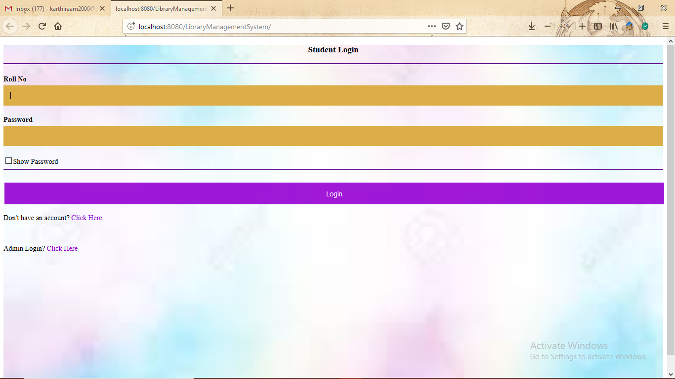
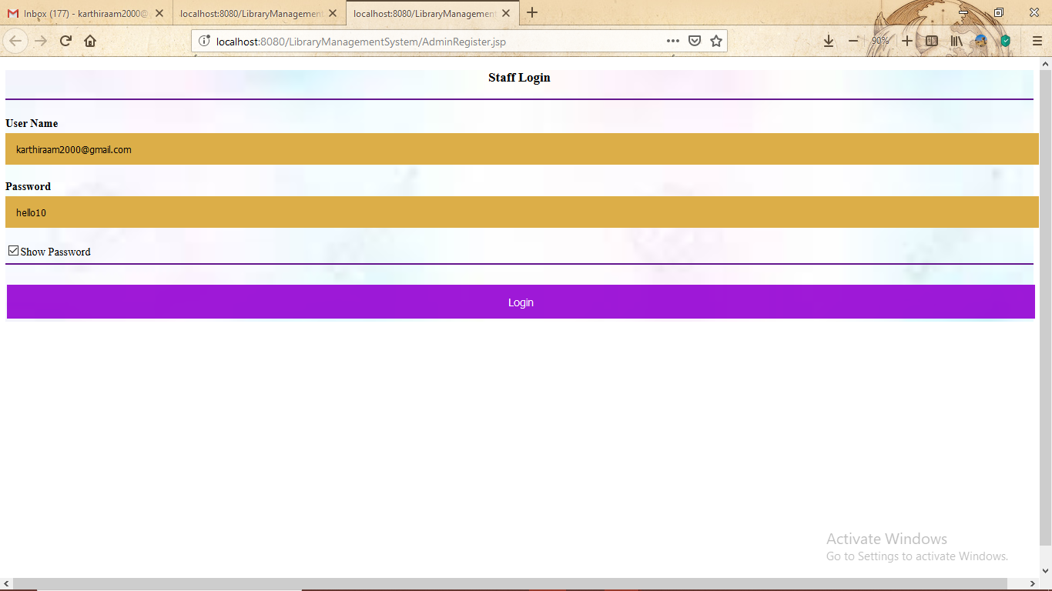
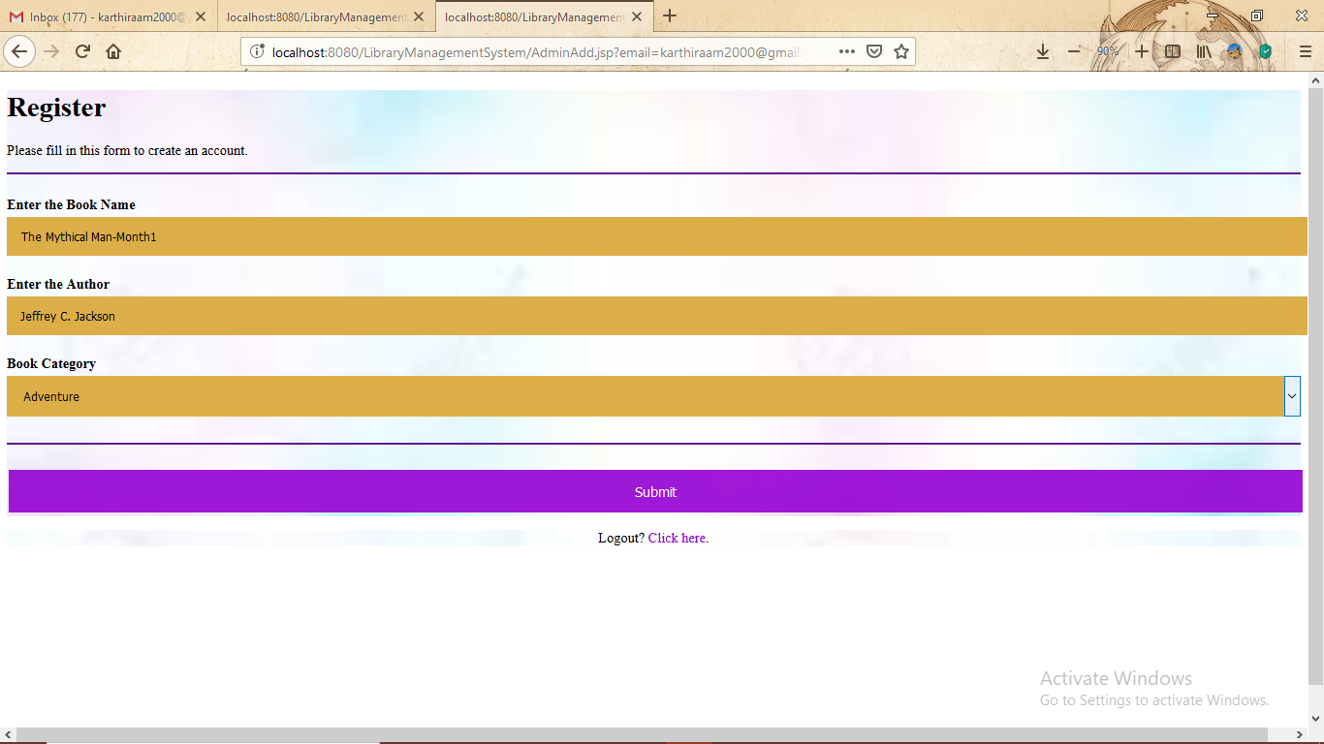

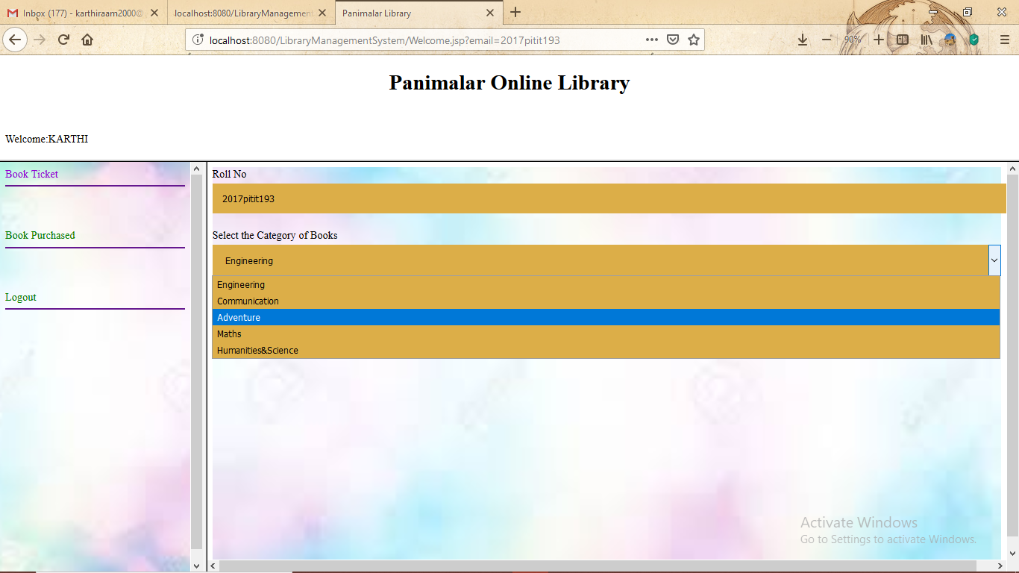
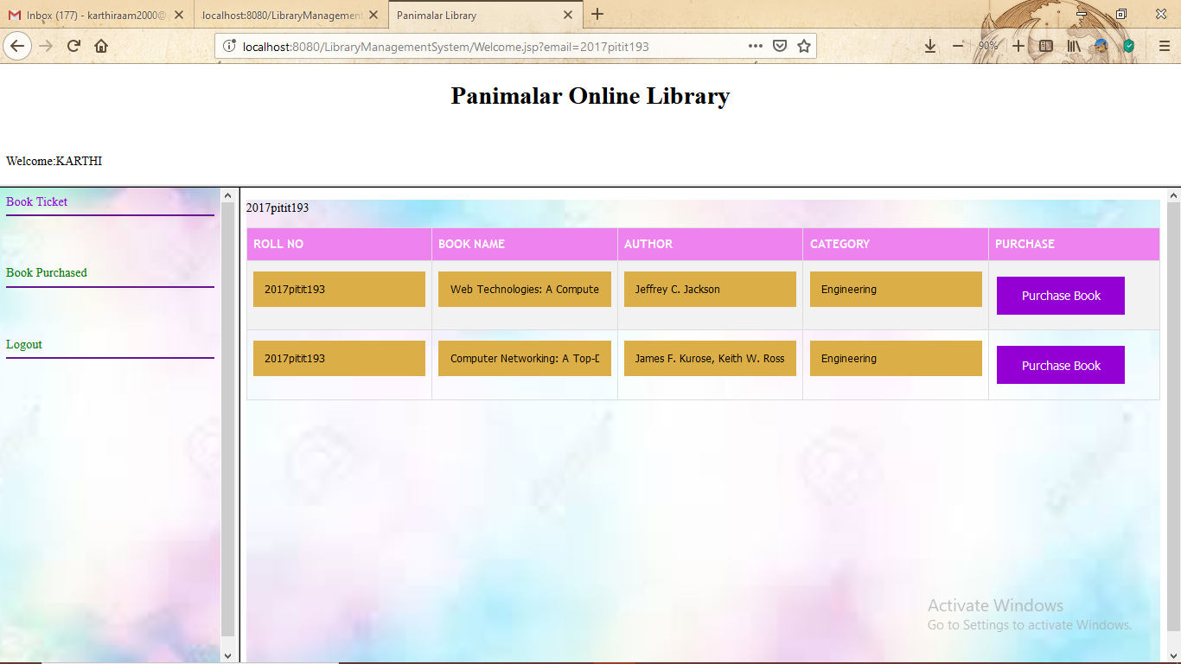
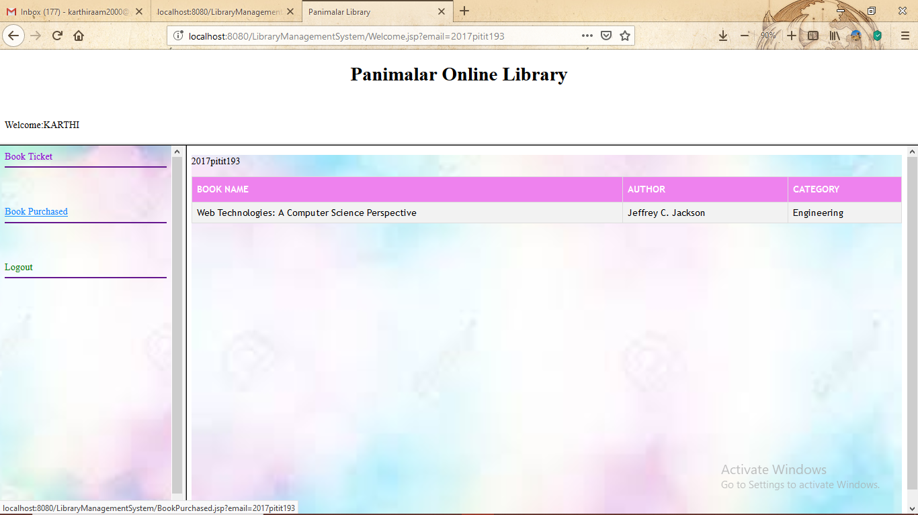

Future scope
To mitigate the issues of conventional and manual method of reservation and distribution of books to readers from library, the online Library Management System has been created. The Library Management System is a web-based online system for assisting both the students/teachers and librarian/staff in borrowing and supervising the books. The system would provide fundamental set of features for adding and/or updating members, adding and/or updating books, getting the list of books, finding out the list of books currently checked out, reserving and borrowing books.

CONCLUSION
The On line Library Management System is developed using JSP and Servlets and MySQL fully meets the objectives of the system for which it has been developed. The system is operated at a high level of efficiency and all the Administrator, students and the Institute associated with the system understand its advantage. The system solves the problem. It was intended to solve as requirement specification.

